Yifeng Huang

ART101 - Programming for the Arts 2024 Spring Quarter

**Lab 3 File Structures 4/19/2024**

**Summary of Efforts**

This is my 2nd submission for this assignment. I got some lost from the previous works and confused how to fulfill the requirement of the assignment. I thought I would do the Lab assignment with some current tools I have but it’s not. Thank you for the teacher’s comments to my 1st submission and giving me the opportunity to re-do it.

I started the GitHub and VS Code installations and configurations from the scratch, and rebuilt the file structure in GitHub and local computer. I learned from this whole re-process a lot more than the beginning.

I re-did this lab assignment following the instructions carefully. I understood more how the GitHub and VS Code work together, and what functions are in the file structure, and how to navigate with it. I will need to learn and practice more on the CSS coding so I can make more prefect web pages in the future assignments.

**Screenshots**

 The file structure:

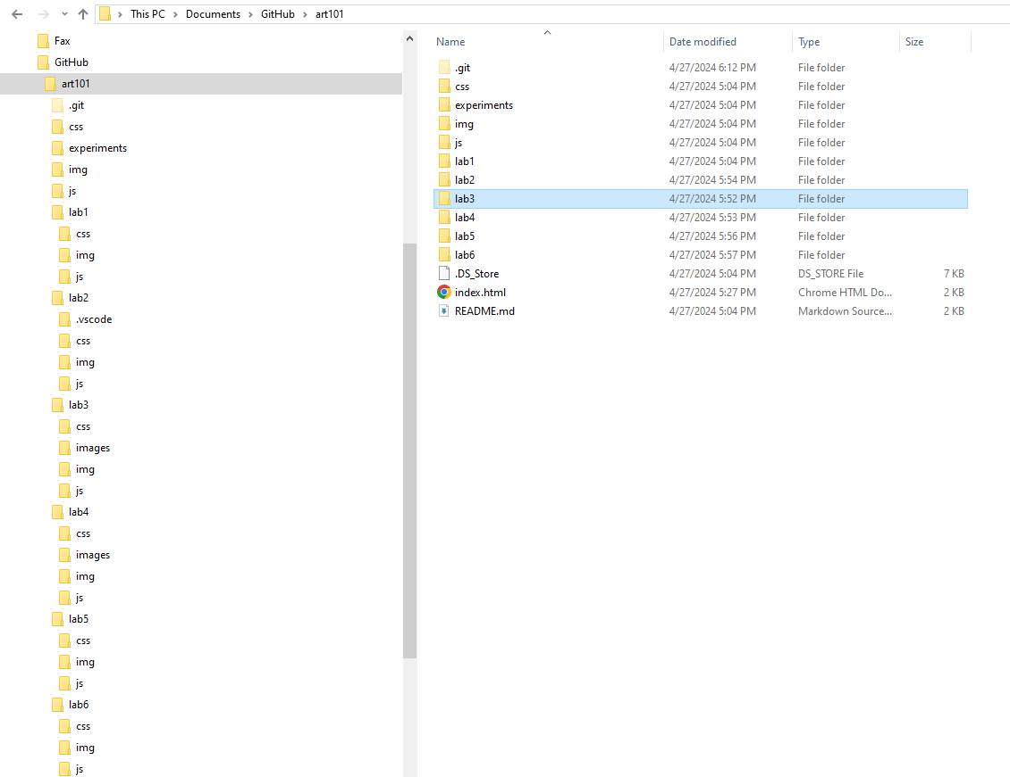

HTML codes for the index file of home page:

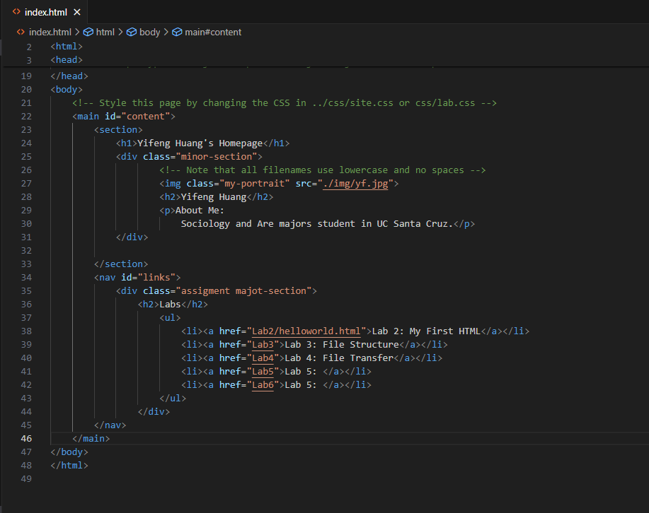

HTML codes for the index file of Lab 3 File Structure page:

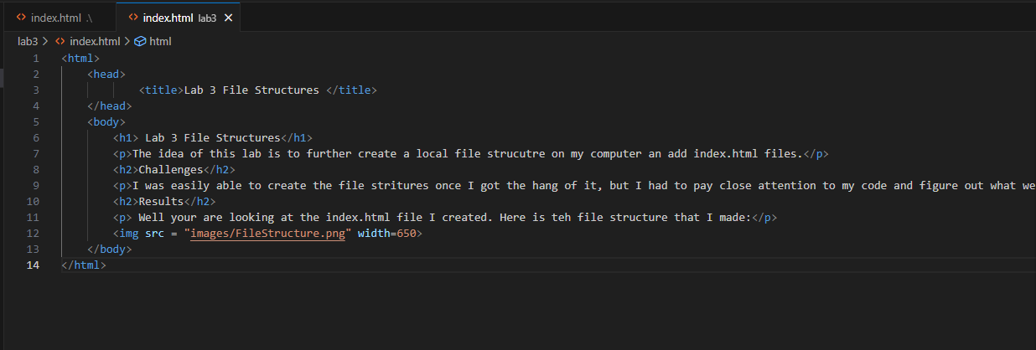

**Self Evaluation Rubric**

|  |  |  |  |  |  |  |
| --- | --- | --- | --- | --- | --- | --- |
| Self Evaluation Rubric | | | | | | |
| Did you complete the assignment and did you complete it on time? | Submitted on time | Up to 1 day late | Up to 2 days late | Up to 3 days late | Up to 4 days late | **Do you need to clarify?** |
| 口 | 口 | 口 | 口 | 口 | 1st submit was on-time. Resubmitted it per teacher’s comments |
| Did you collaborate with a partner? | A lot of effort |  | Some effort |  | Not this time | **Do you need to clarify?** |
| 口 |  | 口 |  | 口 |  |
| Did you put in earnest effort and provide an articulate summary of your experience? | Excellent | Pretty good | About average | Could be improved | Not this time | **What supports this?** |
| 口 | 口 | 口 | 口 | 口 |  |
| Was the assignment complete, with minimal errors, correct output, and good style? | Excellent | Pretty good | About average | Could be improved | Not this time | **What supports this?** |
| 口 | 口 | 口 | 口 | 口 | My 1st submission did not meet what is required. The 2nd submission started over and corrected the mistakes |
| How much EXTRA effort did you put into the assignment? | A lot of extra effort |  | Some extra effort |  | Not this time | **What supports this?** |
| 口 |  | 口 |  | 口 | To better understand how it works, I started over the process from the beginning of the installation to re-do this lab assignment. |
| **Summary of your evaluation/efforts:** | | | | | | |
| I started the GitHub and VS Code installations and configurations from the scratch, and rebuilt the file structure in GitHub and local computer. I learned from this whole re-process a lot more than the beginning.  I re-did this lab assignment following the instructions carefully. I understood more how the GitHub and VS Code work together, and what functions are in the file structure, and how to navigate with it. I will need to learn and practice more on the CSS coding so I can make more prefect web pages in the future assignments. | | | | | | |